The Lions Club of Reading  A Member of the International Association of Lions Clubs  Website: www.readinglions.org.uk  Twitter:@LionsReading  Registered Charity No: 1126848 | 

Reading Lions Charity Fundraising Wine ,Beer and Cider Festival 2013.
Ref: Sponsorship opportunity with Reading Lions

We are holding a Wine, Beer and Cider Festival on Friday 26th and Saturday 27th July at Reading Town Football Club to raise funds for the Duchess of Kent House Charity, Reading Mencap and our Prostate Awareness Day.
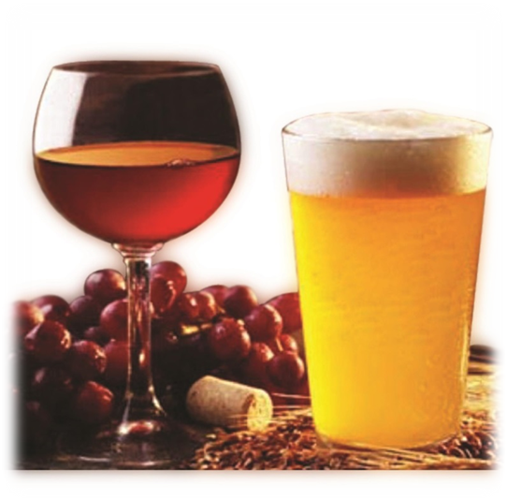
As part of the event, up to 50 beer barrels can be sponsored by companies to increase their local awareness while helping us to raise additional funds. Your company name and logo would be highly visible to hundreds of festival goers.
The cost is £50 per barrel. This would include two free tickets to either Friday or Saturdays Fun.
The main sponsors of the Festival are Loddon Brewery, Southern Fried Chicken and Property Network Online and we are being supported by Reading 107FM.
Barrel sponsors so far include Abbey Windows (Thames Valley) ltd , Franklins Scaffolding Ltd , Voke Flooring and Interiors Ltd , Cryer Sandham Ltd , Huey Construction Ltd , Kremer Motor Body Repairs Ltd ,OrmeComm Telecommunications Specialists , Tilby Ltd , Wilmotts (Reading) Ltd., Southern Remedial Services Ltd. , Tilehurst Village Butchers ,Guest Services Ltd , Fanny`s Antiques , J.C. Properties., Sun Mobility ,Sunkoshi Nepalese Restaurant ,Regency Dry Cleaning and The Ironing Lady Ltd.
Please contact Eric Warner to sponsor a Barrel
Tel: 07974 454945
Web site: www.readinglions.org.uk
And for tickets online see :-
www.reading107.com
Supported By
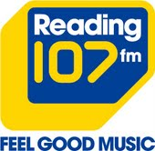
__________________________________________________________________________________
‘We Serve’

